CISCO NSO Service Provisioning
Acceptance Test Procedure Document
Environment: CFS 172.28.2.17 RFS 172.28.2.18, 172.28.2.19, 172.28.2.20
LSA Deployment (CFS/RFS)
Cisco Network Services Orchestrator (NSO)
CLI and Web UI Test Procedures — Tejas EMS Integration

Revision History
Revision No. | Date of Submission | Description of Revision | Prepared By | Date of submission for Review | Review completed Date
1.0 | 07th Jul26 | Initial version |  | 07-07-2026

Prepared by | Reviewed By | Approved by

Table of Contents
1. Introduction 3
Deployment Details 3
2. Test Case Summary 3
3. NSO Service Configuration and Lifecycle Management 3
Test Case 1: Provisioning a New Service Instance 4
Test Case 2: Committing the Service Configuration 5
Test Case 3: Deleting a Service Instance 5
4: The Cluster Architecture — Nodes, Roles,Node Type,IP 6
- 4.1 Cluster Node Reference Table 6
5. User Interface and System Verification 6
- 5.1 Web Portal and EMS Verification 7
- Test Case 4: RFS Cluster Lock/Unlock — Baseline (All Nodes Unlocked) 7
- Test Case 5: RFS Cluster Lock/Unlock — Partial Lock (RFS-18 & RFS-20 Locked) 13
- Test Case 6: RFS Cluster Lock/Unlock — Alternate Partial Lock (RFS-18 & RFS-19 Locked) 17

1 Introduction
This acceptance test plan provides the tests performed on the Cisco NSO (Network Services Orchestrator) platform to evaluate the automation, provisioning, and management functionalities offered for the T-Fiber network, covering the LSA (Layered Service Architecture) deployment across RFS (Resource Facing Service) and CFS (Customer Facing Service) layers.
The acceptance testing included verification of NSO system status, user access, device inventory, package operational status, service configuration, service commit operations, service deletion, and service visibility across CFS, RFS, and Tejas EMS. Additional tests were performed to validate service behavior under different RFS cluster lock and unlock scenarios.

Site / Node Details
Environment | 172.28.2.17 (CFS - Customer Facing Service)
RFS Node | 172.28.2.18 (RFS - Resource Facing Service)
Cluster Nodes | RFS-18, RFS-19, RFS-20
Deployment Type | LSA (Layered Service Architecture) - RFS/CFS
Field Management System | Tejas EMS

2 Test Cases summary
The table below summarizes each verification step performed. Detailed procedure, expected result, and supporting evidence (screenshots) are documented against each test case.
# | Checkpoint | What It Confirms | Type | Result
1 | Provisioning a New Service Instance | The required service parameters (device, OLT, ONT, customer ID, VLANs, bandwidth profile) can be successfully configured in NSO. | CLI | PASS
2 | Committing the Service Configuration | The configured service transaction commits successfully in NSO with no errors. | CLI | PASS
3 | Deleting a Service Instance | An existing service instance can be removed from NSO and the deletion commits success. | CLI | PASS
4 | Cluster Node Role & Status Verification | Confirmed RFS-18 (Leader), RFS-19 & RFS-20 (Followers) are correctly configured and Unlocked. | Web UI | PASS
5 | RFS Cluster Lock/Unlock — Baseline (All Nodes Unlocked) | With all RFS nodes Unlocked, a provisioned service is visible across CFS, RFS, and Tejas EMS, and is fully removed from all three after deletion. | Web UI | PASS
6 | RFS Cluster Lock/Unlock — Partial Lock (RFS-18 & RFS-20 Locked) | Service provisioning and visibility across CFS, RFS, and Tejas EMS remain unaffected when RFS-18 and RFS-20 are Locked and RFS-19 is Unlocked. | Web UI | PASS
7 | RFS Cluster Lock/Unlock — Alternate Partial Lock (RFS-18 & RFS-19 Locked) | Service provisioning and visibility across CFS, RFS, and Tejas EMS remain unaffected when RFS-18 and RFS-19 are Locked and RFS-20 is Unlocked. | Web UI | PASS

3.NSO Service Configuration and Lifecycle Management
In this section we covers a service instance within NSO – from initial configuration through commit and eventual deletion all performed via the command line interface
Test Case 1: Provisioning a New Service Instance
Description: | Verify that a service instance can be configured in NSO by supplying the required service parameters — device name, OLT details, ONT details, customer ID, VLANs, and bandwidth profile.
Procedure: | 1. Enter the service configuration mode:  services SERVICE_TEMPLATE SERVICE_INSTANCE_ID  2. Configure the required service parameters, including:  - Device name and package  - OLT IP address  - ONT serial number, model, and port  - C-VLAN and S-VLAN  - Customer ID  - Bandwidth profile  - Provisioning mode and VLAN tagging  - PON port details
Expected Result: | The configuration should accept and display the provided parameters within the NSO configuration session.
Result: | ☐ OK ☐ Not OK
Logs/Snaps: (if Any)

Test Case 2: Committing the Service Configuration
Description: | Verify that a configured service transaction can be committed in NSO.
Procedure: | 1. Execute:  commit `
Expected Result: | The service configuration transaction should be committed successfully.
Result: | ☐ OK ☐ Not OK
Logs/Snaps: (if Any) | Confirmation that the order committed successfully.
Test Case 3: Deleting a Service Instance
Description: | Verify that an existing service instance can be removed from NSO and that the deletion is committed.
Procedure: | 1. Enter configuration mode:  config terminal  2. Delete the target service instance:  no services SERVICE_TEMPLATE SERVICE_INSTANCE_ID `  3. Commit the change:  - commit
Expected Result: | The specified service instance is deleted, and the commit completes successfully.
Result: | ☐ OK ☐ Not OK
Logs/Snaps: (if Any) | Confirmation of deletion commit success for SERVICE_INSTANCE_ID.

4. The Cluster Architecture — Nodes, Roles, Node Type, IP
4.1 Cluster Node Reference Table
Node | Role | Node Type | IP Address
CFS | Central Orchestrator | CFS | 172.28.2.17
RFS-18 | Leader | RFS | 172.28.2.18
RFS-19 | Follower | RFS | 172.28.2.19
RFS-20 | Follower | RFS | 172.28.2.20
This chapter validates the Lock/Unlock behavior of RFS cluster nodes. RFS-18 serves as the Leader, while RFS-19 and RFS-20 operate as Followers. Each scenario confirms that service orders remain visible and manageable across CFS, RFS, and the Tejas EMS field management system under varying node lock-state combinations.
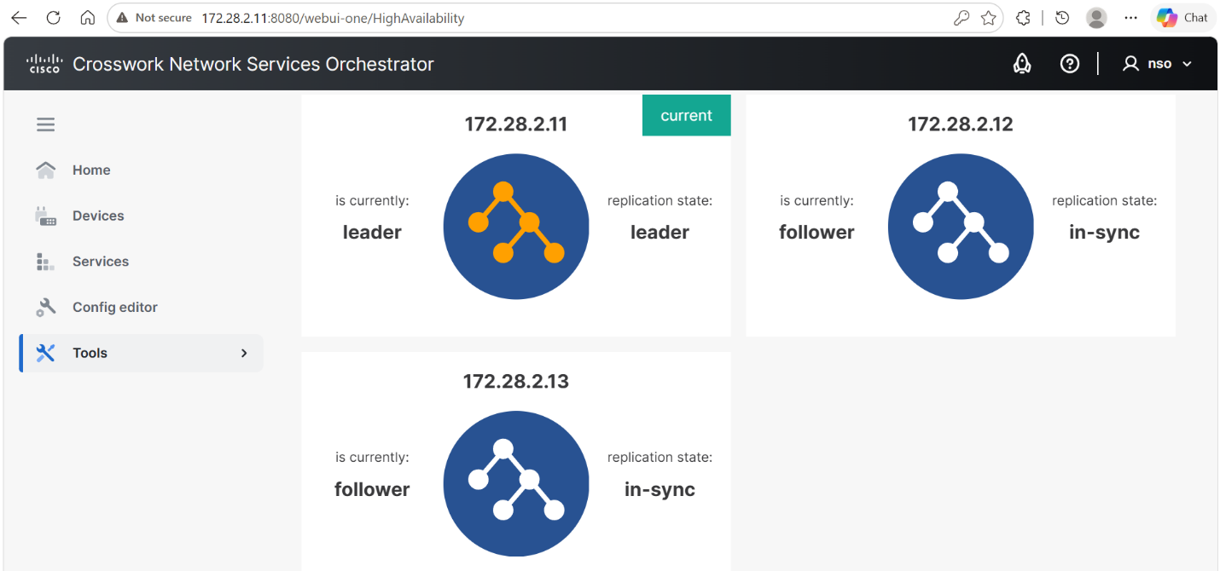

5 User Interface and System Verification
These test cases run against the web-facing systems — the CFS (172.28.2.17) and RFS (172.28.2.18) dashboards, along with the Tejas EMS field management application — confirming that CLI-driven automated changes are correctly reflected in the systems used daily by business and field teams.
Component | Role | IP Address / Identifier
CFS (Customer Facing Service) | Central orchestration node used for order submission & verification | 172.28.2.17
RFS (Resource Facing Service) Web Portal | Field-facing service node used for order verification | 172.28.2.18
Tejas EMS | Third-party Element Management System for OLT field device verification | Integrated via NBI

5.1 Web Portal and EMS Verification
Test Case 4: RFS Cluster Lock/Unlock — Baseline (All Nodes Unlocked)
Description: | Verify that all RFS cluster nodes (RFS-18, RFS-19, RFS-20) remain in the Unlocked state, and validate end-to-end service provisioning and deletion visibility across CFS, RFS, and Tejas EMS.
Procedure: | - Verify RFS-18's administrative state in the NSO Web UI — confirm Unlocked.  - Verify RFS-19's administrative state — confirm Unlocked.  - Verify RFS-20's administrative state — confirm Unlocked.  - Submit the service provisioning request from the SCCM application to NSO via the RESTCONF API. (See sample payload below.)  - Verify the RESTCONF request is accepted by NSO.  - Search for the Service ID in CFS (172.28.2.17) — confirm the service instance appears.  - Search for the Service ID in RFS (172.28.2.18) — confirm the service instance appears.  - Search for the ONT Serial Number in Tejas EMS — confirm the provisioned service appears.  - Select the service instance in CFS and perform the Delete operation.  - Confirm the deletion request.  - Search for the Service ID in CFS — confirm no instance is displayed.  - Search for the Service ID in RFS — confirm no instance is displayed.  - 13. Search for the ONT Serial Number in Tejas EMS — confirm no service records remain.
Expected Result: | All three RFS nodes display as Unlocked. The SCCM-submitted provisioning request is accepted by NSO, with the resulting service visible across CFS, RFS, and Tejas EMS. Following deletion, the service disappears from all three systems.
Result: | ☐ OK ☐ Not OK
Logs/Snaps: (if Any) | RFS-18 (Leader) confirmed in the Unlocked state.  RFS-19 (Follower) confirmed in the Unlocked state.  RFS-20 (Follower) confirmed in the Unlocked state.  (Above Payload is passed from SCCM Application )  All RFS cluster nodes (18, 19, 20) confirmed Unlocked.  Committed service order found in CFS (172.28.2.17) by Service ID.  Committed service order found in RFS (172.28.2.18) by Service ID.  OLT service provisioning confirmed in Tejas EMS by ONT Serial Number.  Service order deleted from CFS (172.28.2.17) by Service ID.  Deletion confirmed in CFS (172.28.2.17) by Service ID.  Deletion confirmed in RFS (172.28.2.18) by Service ID.  Service removal confirmed in Tejas EMS by ONT Serial Number.

Test Case 5: RFS Cluster Lock/Unlock — Partial Lock (RFS-18 & RFS-20 Locked)
Description: | Verify that RFS-18 and RFS-20 remain in the Locked state while RFS-19 stays Unlocked, and validate that service provisioning and visibility across CFS, RFS, and Tejas EMS remain unaffected despite the partial lock.
Procedure: | 1. Verify RFS-18's administrative state — confirm **Locked**.  2. Verify RFS-19's administrative state — confirm **Unlocked**.  3. Verify RFS-20's administrative state — confirm **Locked**.  4. Submit the service provisioning request from the SCCM application to NSO via the RESTCONF API. *(See sample payload below.)*  5. Verify the RESTCONF request is accepted by NSO.  6. Search for the Service ID in CFS (172.28.2.17) — confirm the service instance appears.  7. Search for the Service ID in RFS — confirm the service instance appears.  8. Search for the ONT Serial Number in Tejas EMS — confirm the provisioned service appears.  9. Select the service instance in CFS and perform the **Delete** operation.  10. Confirm the deletion request.  11. Search for the Service ID in CFS — confirm no instance is displayed.  12. Search for the Service ID in RFS — confirm no instance is displayed.  13. Search for the ONT Serial Number in Tejas EMS — confirm no service records remain.
Expected Result: | RFS-18 and RFS-20 display as Locked, while RFS-19 displays as Unlocked. Despite this partial lock state, the service provisioning request is accepted by NSO, with the resulting service visible across CFS, RFS, and Tejas EMS.
Result: | ☐ OK ☐ Not OK
Logs/Snaps: (if Any) | RFS-18 confirmed in the Locked state.  RFS-20 confirmed in the Locked state.  RFS-19 confirmed in the Unlocked state.  CFS (172.28.2.17) service order search — result 1.  CFS (172.28.2.17) service order search — result 2.  CFS (172.28.2.17) service order confirmed present by Service ID.

Test Case 6: RFS Cluster Lock/Unlock — Alternate Partial Lock (RFS-18 & RFS-19 Locked)
Description: | Verify that RFS-18 and RFS-19 remain in the Locked state while RFS-20 stays Unlocked, and validate that service provisioning and visibility across CFS, RFS, and Tejas EMS remain unaffected under this alternate lock configuration.
Procedure: | 1. Verify RFS-18's administrative state — confirm **Locked**.  2. Verify RFS-19's administrative state — confirm **Locked**.  3. Verify RFS-20's administrative state — confirm **Unlocked**.  4. Submit the service provisioning request from the SCCM application to NSO via the RESTCONF API. *(See sample payload below.)*  5. Verify the RESTCONF request is accepted by NSO.  6. Search for the Service ID in CFS (172.28.2.17) — confirm the service instance appears.  7. Search for the Service ID in RFS — confirm the service instance appears.  8. Search for the ONT Serial Number in Tejas EMS — confirm the provisioned service appears.  9. Select the service instance in CFS and perform the **Delete** operation.  10. Confirm the deletion request.  11. Search for the Service ID in CFS — confirm no instance is displayed.  12. Search for the Service ID in RFS — confirm no instance is displayed.  13. Search for the ONT Serial Number in Tejas EMS — confirm no service records remain.
Expected Result: | RFS-18 and RFS-19 display as Locked, while RFS-20 displays as Unlocked. Despite this alternate partial lock state, the service is successfully provisioned and remains visible across CFS, RFS, and Tejas EMS.
Result: | ☐ OK ☐ Not OK
Logs/Snaps: (if Any) | RFS-18 and RFS-19 confirmed in the Locked state; RFS-20 confirmed Unlocked — result 1.  RFS-18 and RFS-19 confirmed in the Locked state; RFS-20 confirmed Unlocked — result 2.  RFS-18 and RFS-19 confirmed in the Locked state; RFS-20 confirmed Unlocked — result 3.  Committed service order seen in CFS (172.28.2.17).  Committed service order seen in RFS (172.28.2.18).  Corresponding service confirmed in Tejas EMS.

